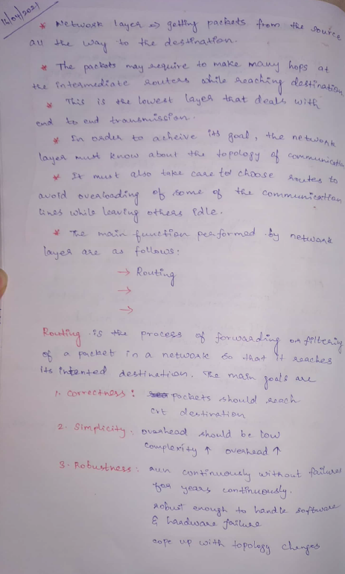 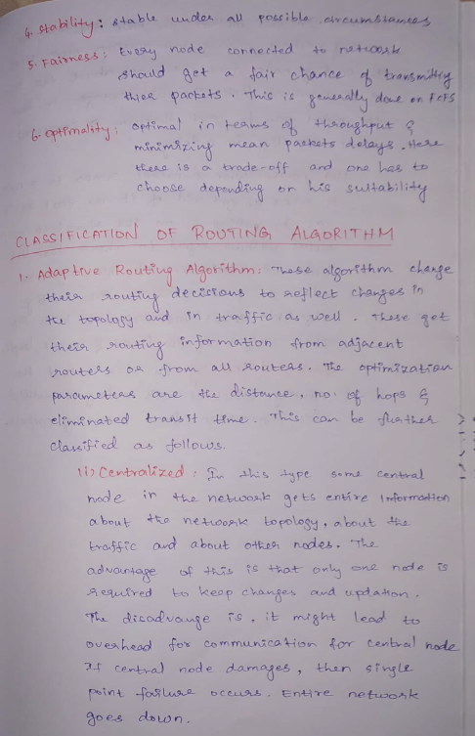

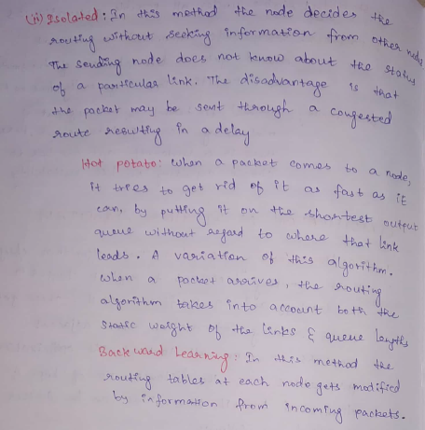

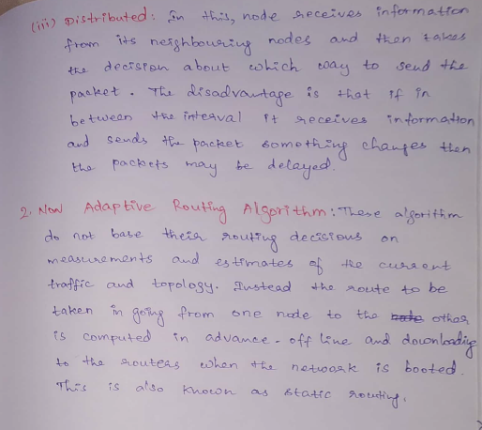

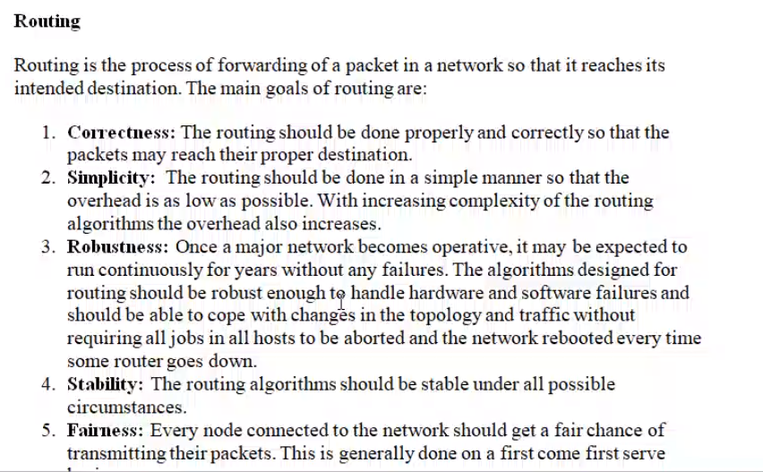

When two nodes (source and destination) are in same network 🡪 filter  
When two nodes (source and destination) are in different network 🡪 forwarding

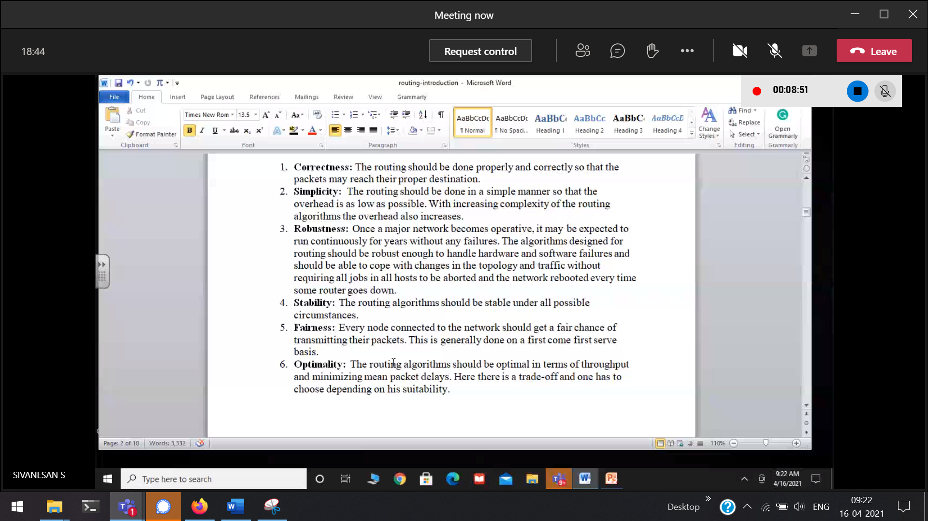

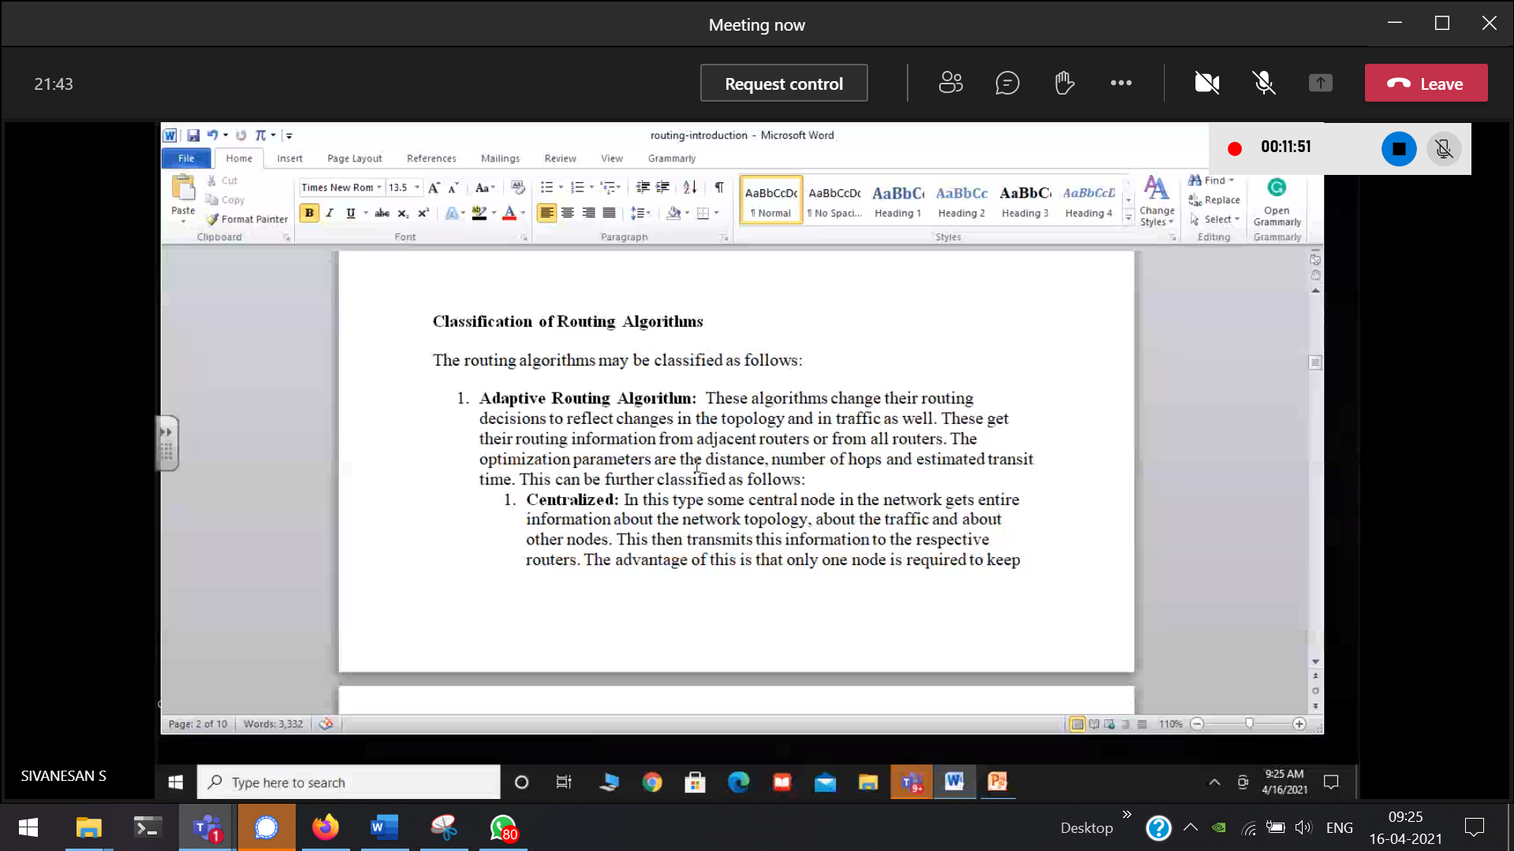

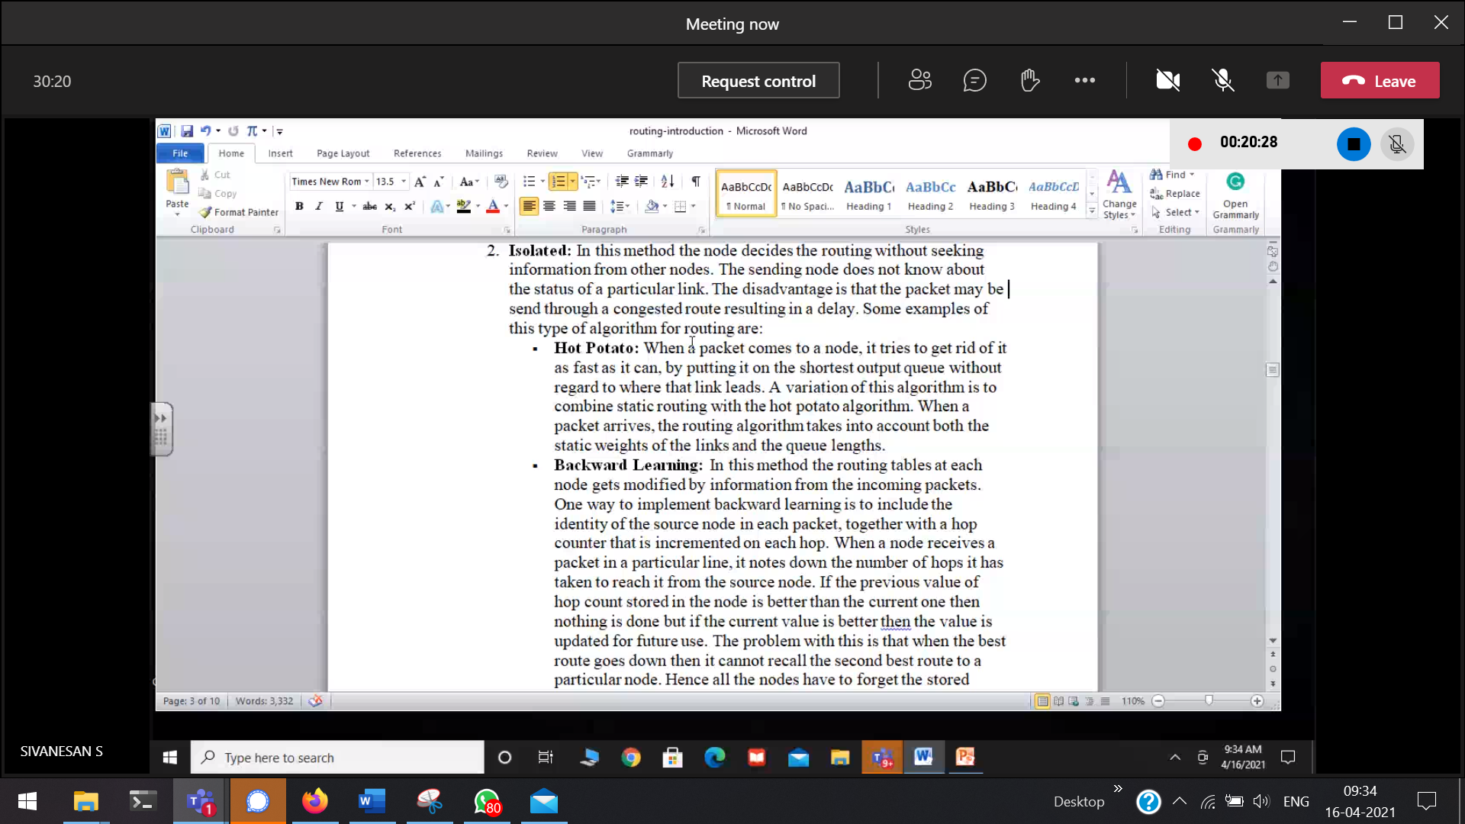

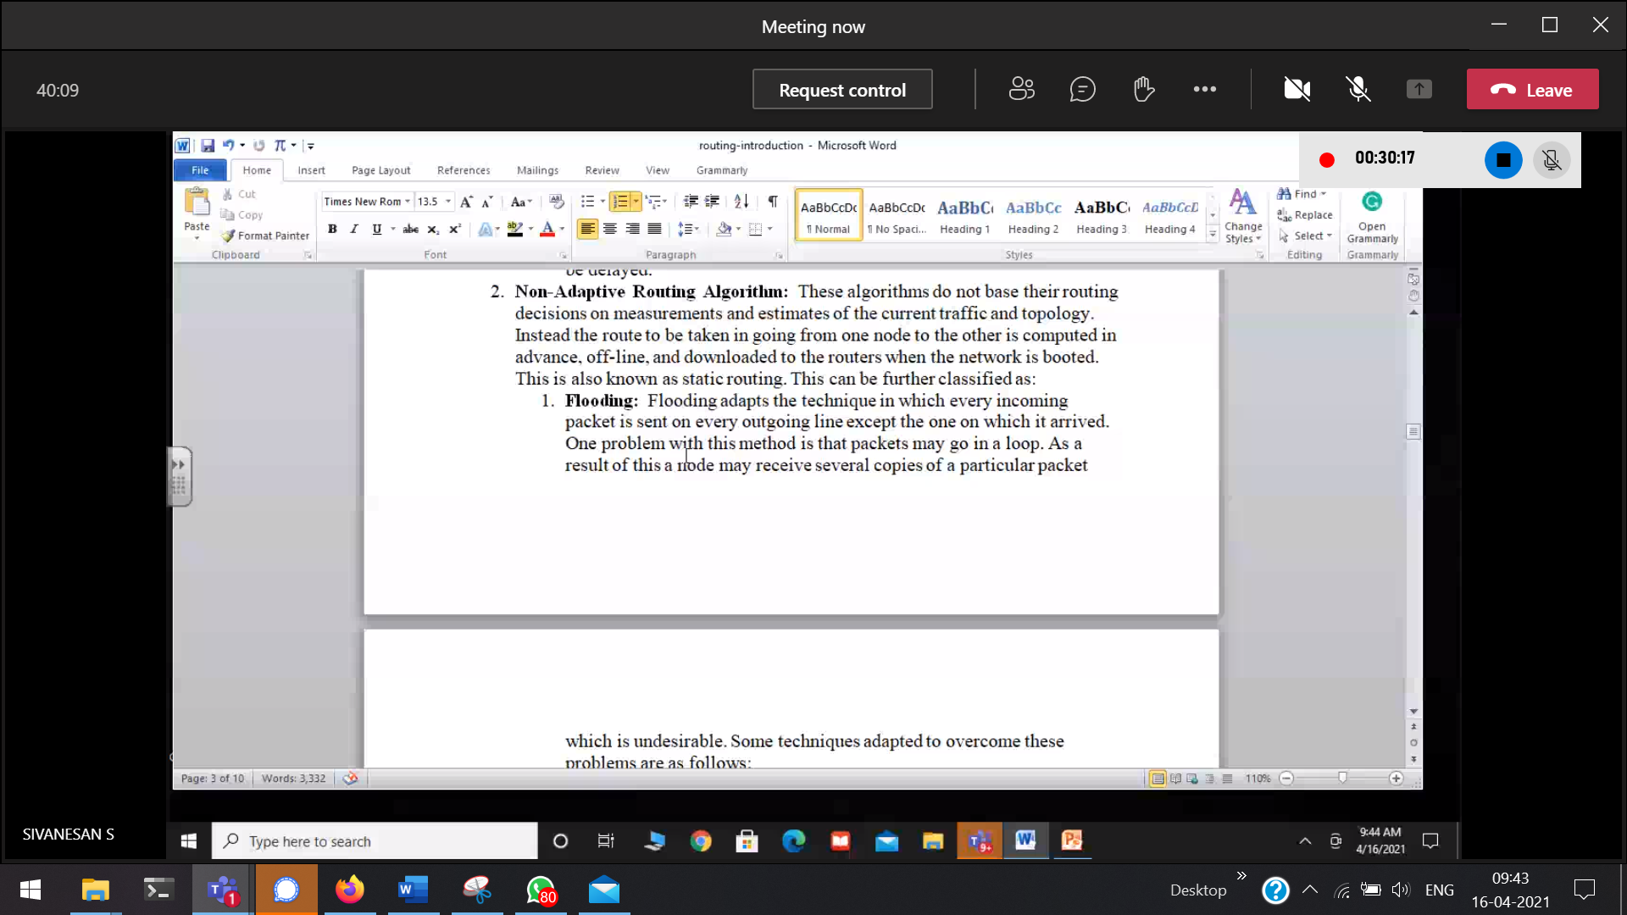

Adaptive 🡪 learning principle is there   
Non-adaptive 🡪 learning principle is not there

# Routing Algorithm

How to move a packet from a PC in one network to a PC in another network. This is done with the help of Routing.

## **Direct Delivery**

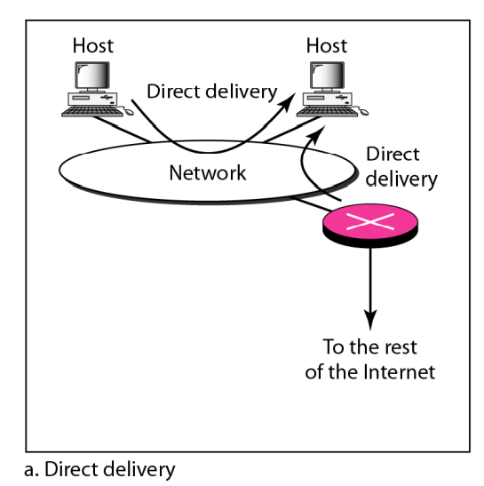

Both the hosts (source and destination) are in the same network. So they do not require any gateway routers(pink cross). The packets need not go out of the network.

## **In-Direct Delivery**

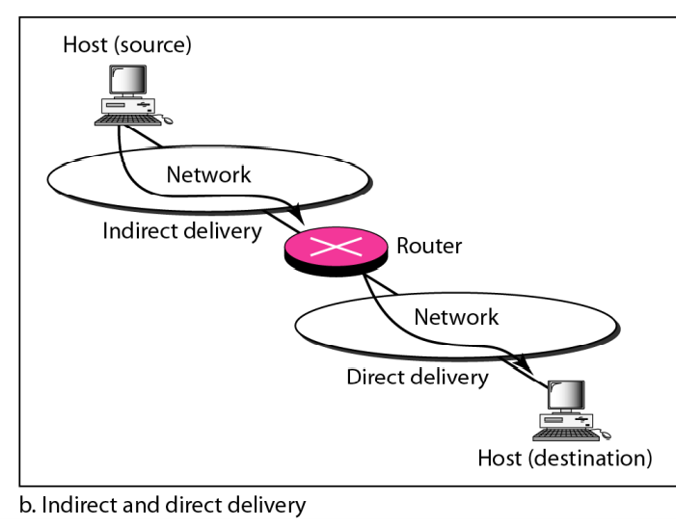

Source to its gateway-router.  
gateway-Router to its Source.  
Both requires Direct Delivery

# **Unicasting Routing**

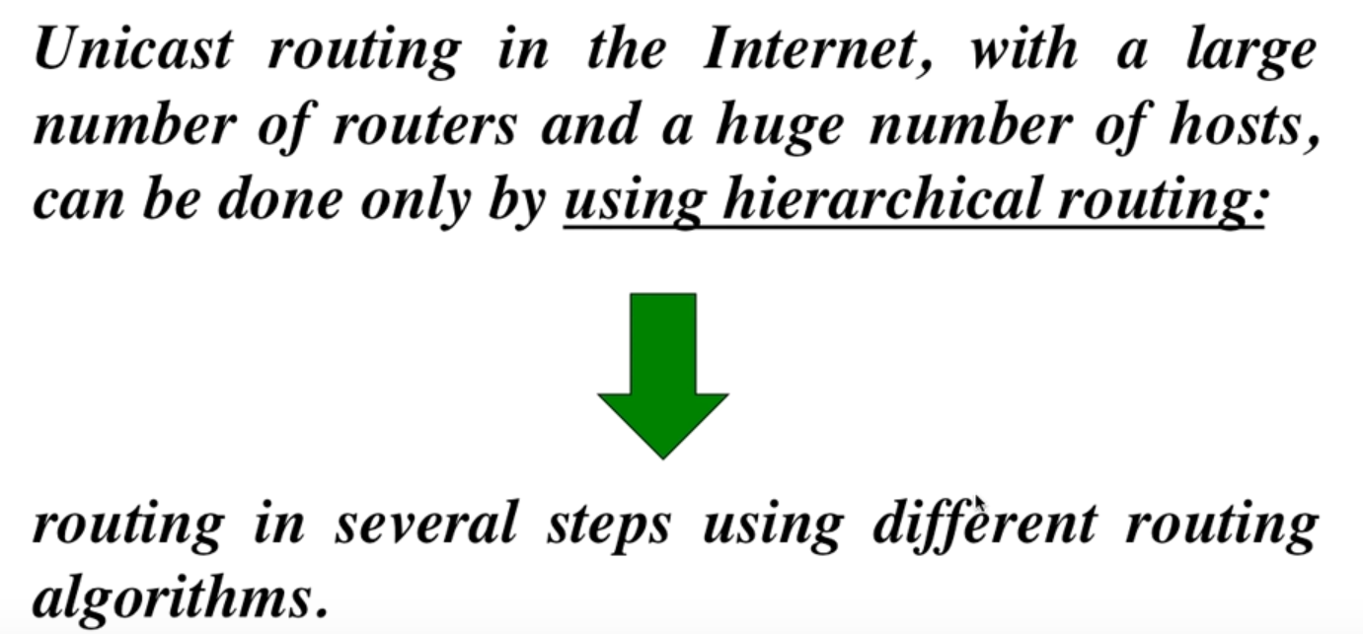

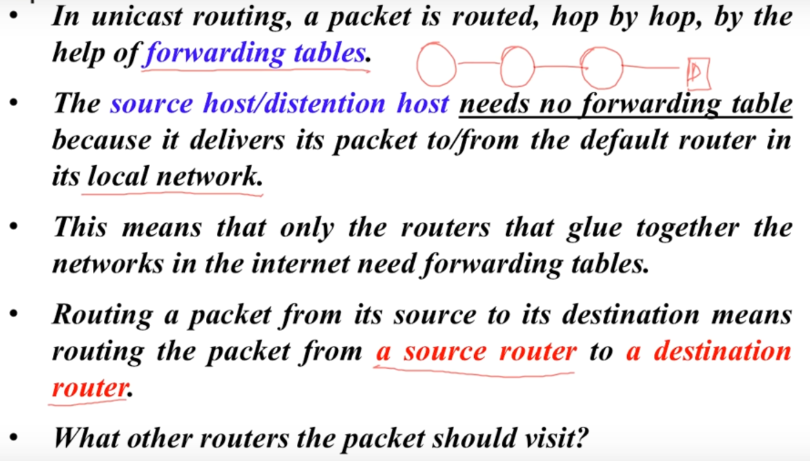

# **Least Cost Routing**

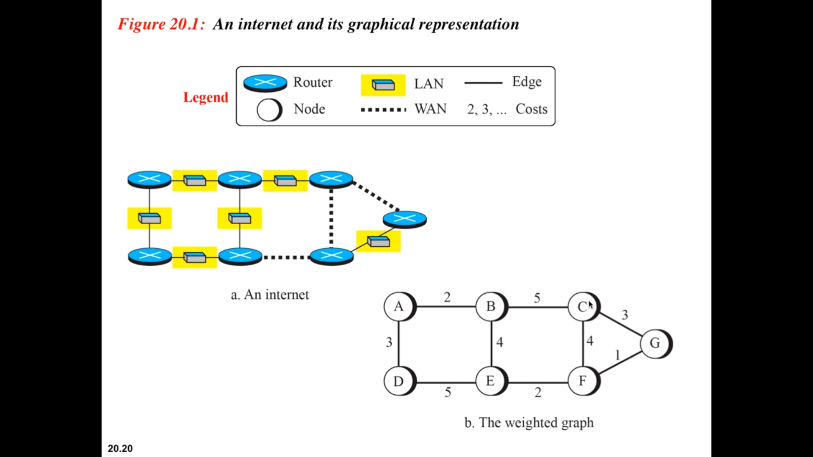

The internet is represented in the form of a weighted graph.

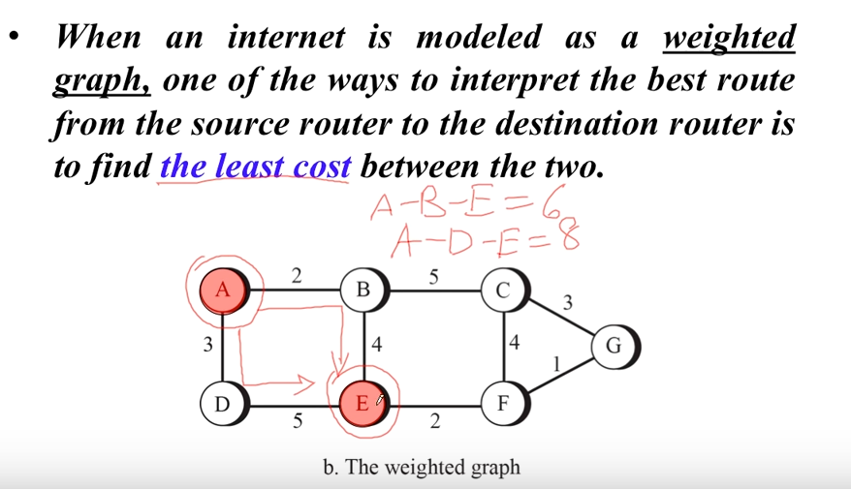

Direct neighbours 🡪 will always have the least cost.

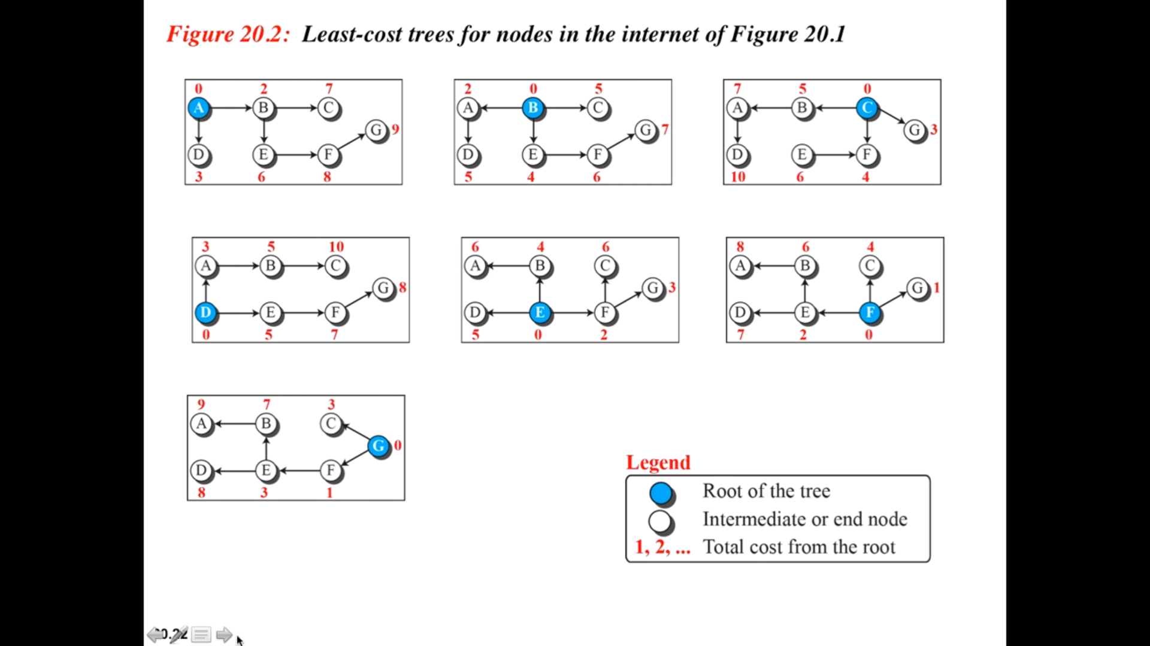

Shortest distance from the respective node.

# **Routing Protocols**

Routing protocol 🡪   
Routable protocol 🡪

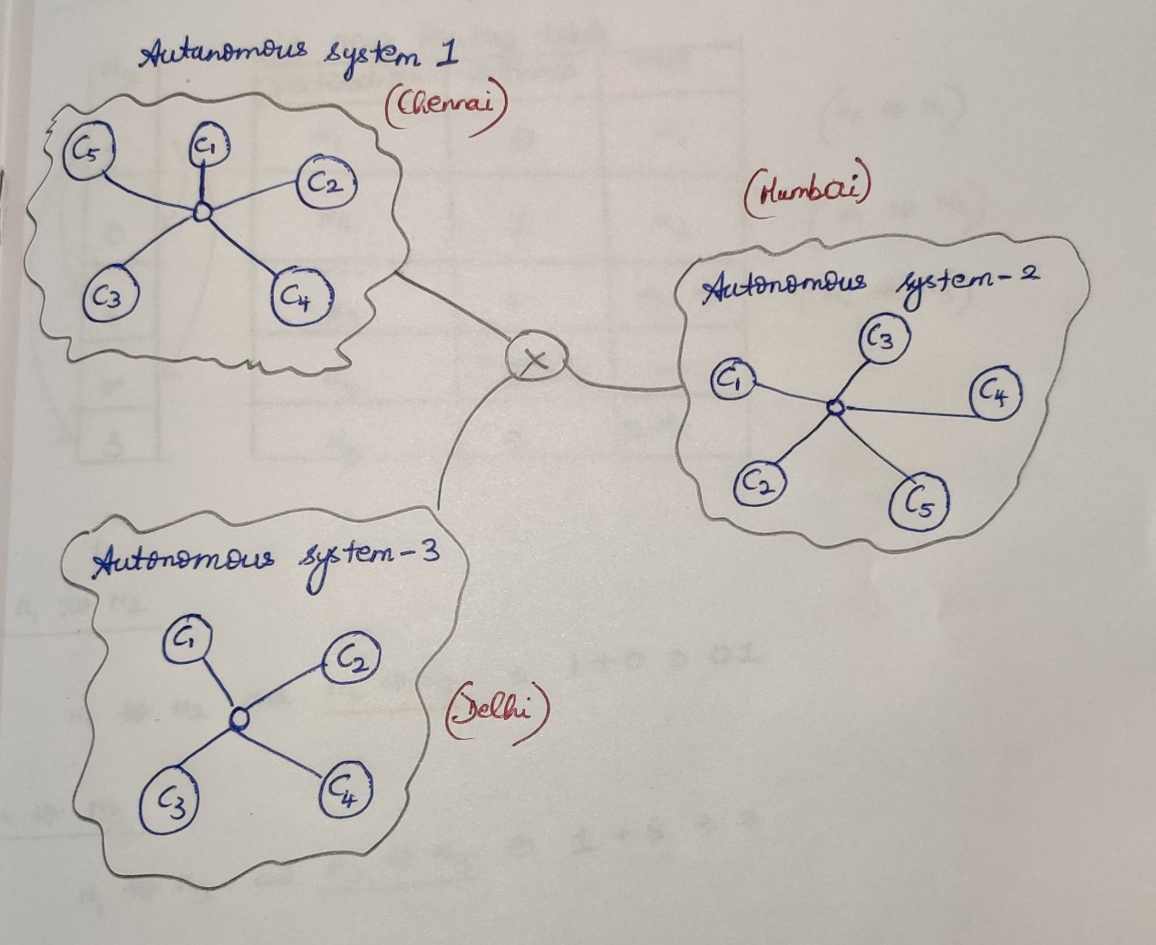

Intra-domain [Within a autonomous system] / Interior Gate-way Protocol  
Within Chennai / within Mumbai communication takes place.

Inter-domain [Between the autonomous systems] / Exterior Gate-way Protocol  
Chennai, Mumbai and Delhi are communicating with each-other.

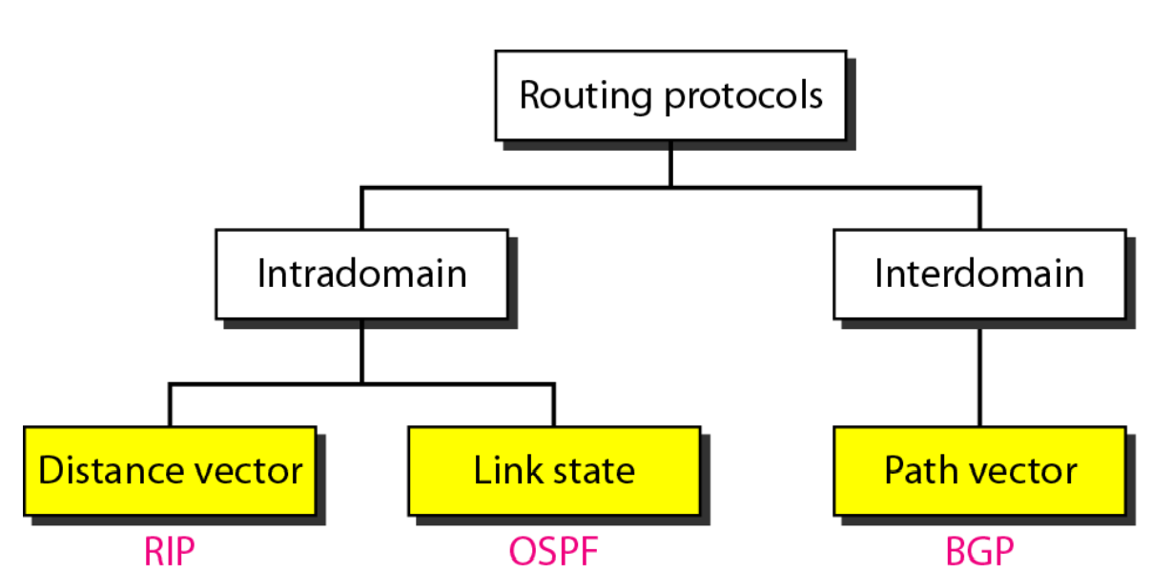

## **Intra-domain**

### **Distance Vector Routing [RIP 🡪 Routing Information Protocol]**

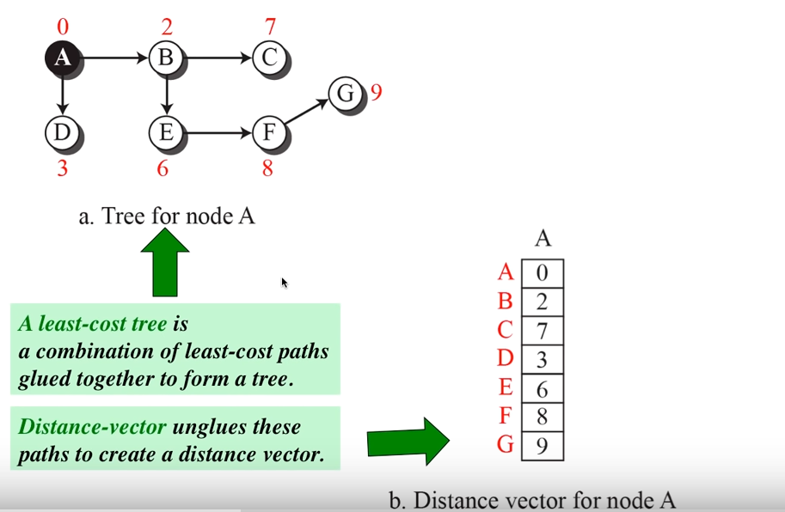

Neighbours will start to exchange information with each-other.  
This takes place in two different times.

If a router experiences some change in its vector, it will immediately inform to its neighbours about this change.

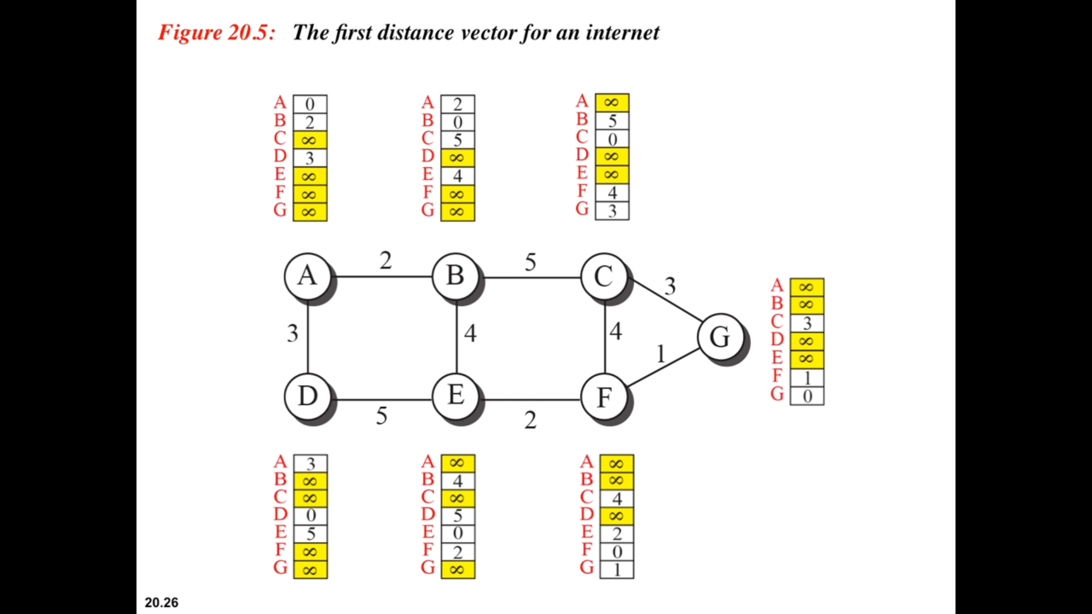

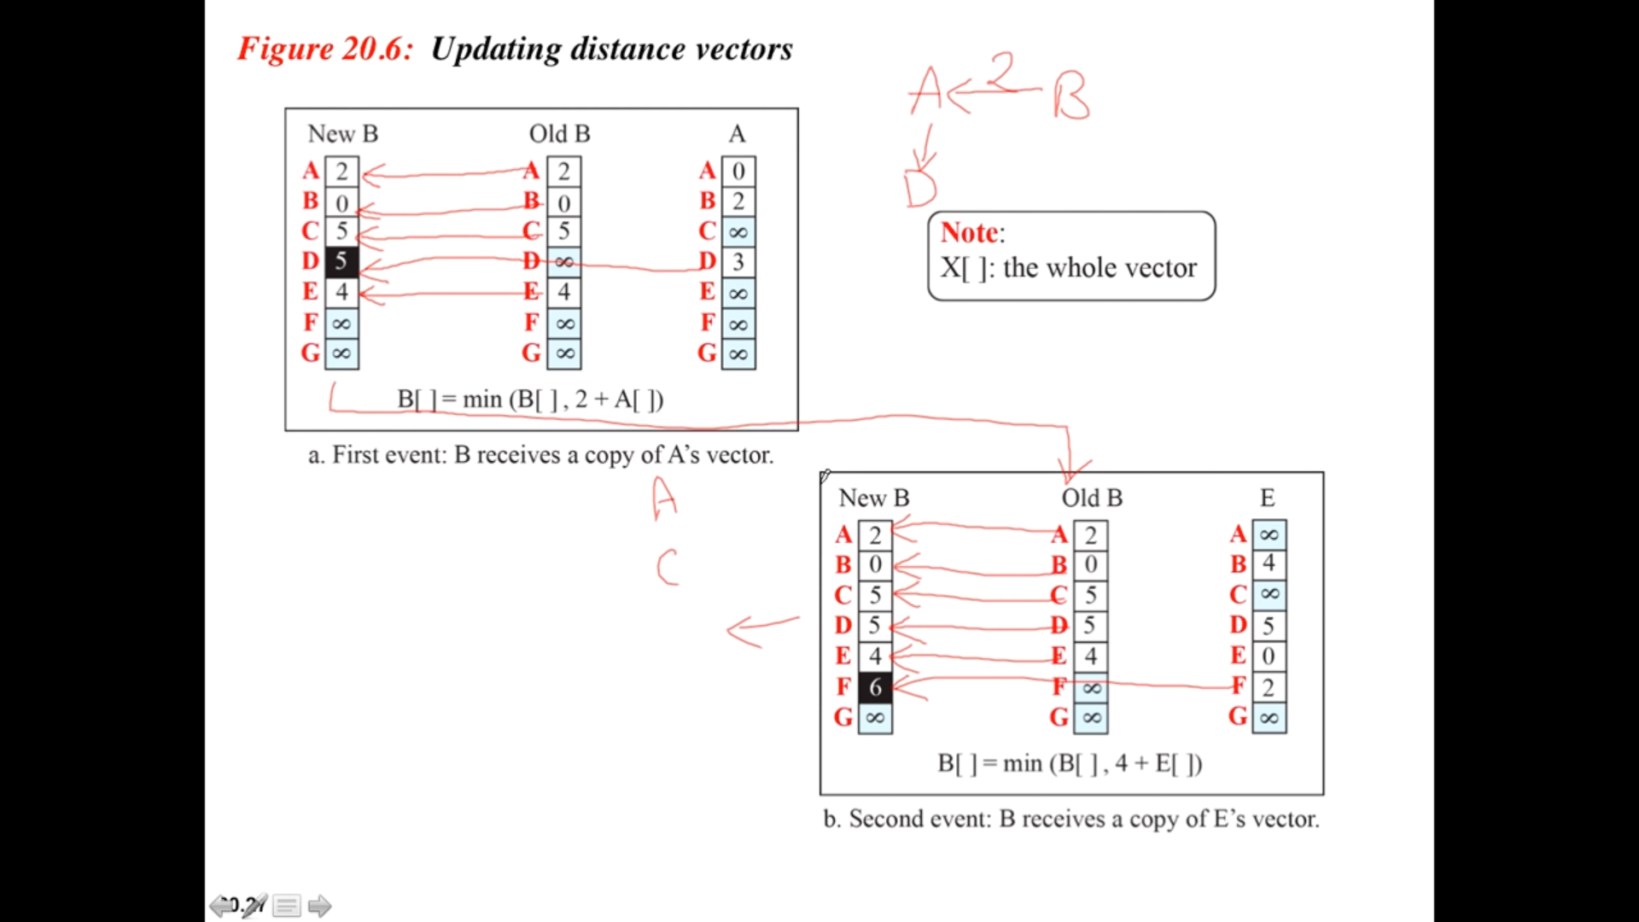

N1’s routing table

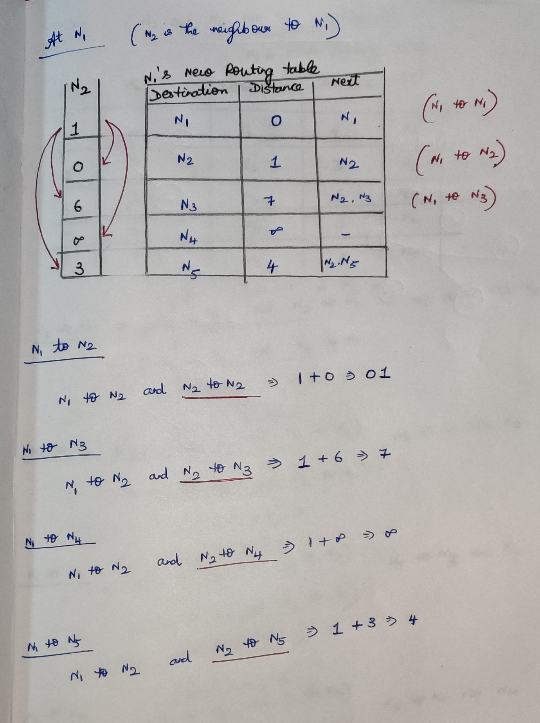

N5’s routing table

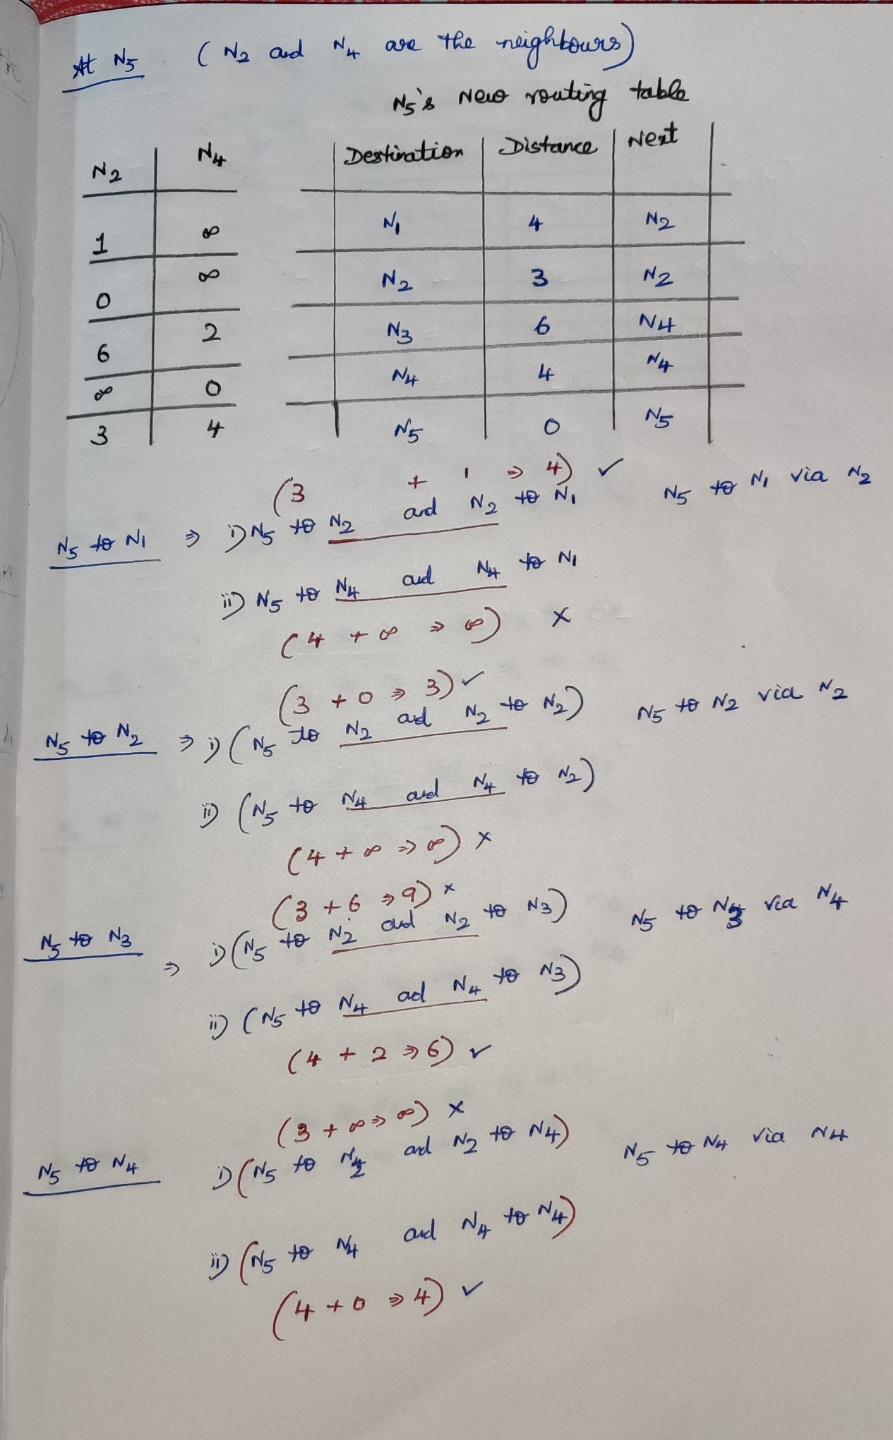

N4’s routing table

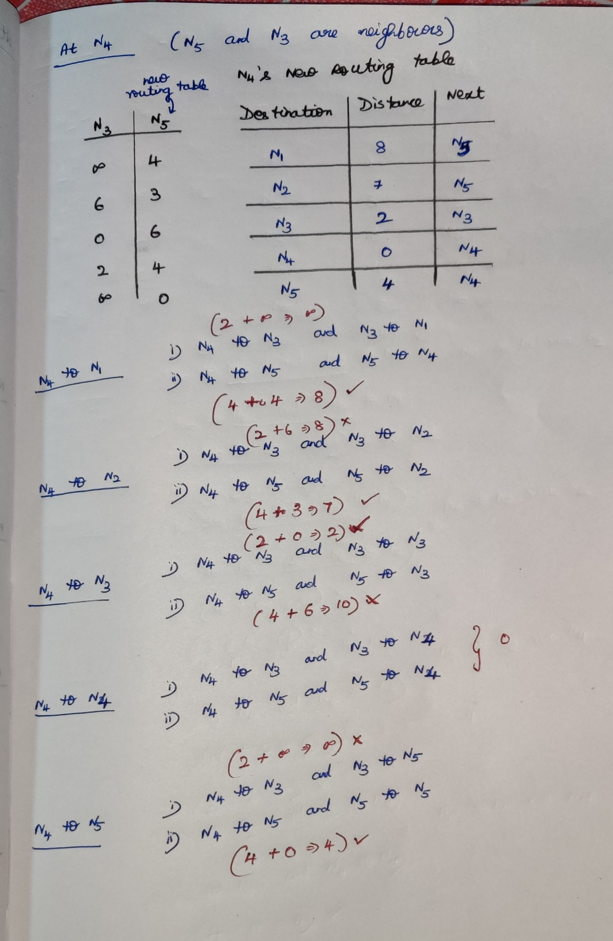

### **Link State Routing [OSPF 🡪 Open Shortest First Path]**

Link state routing uses Dijkstra’s algorithm

## **Inter-domain**

### Path-vector [BGP]